Copyright
PROJECT MANAGEMENT SOFTWARE CENTRE 1994-2004
All rights reserved. No part of this publication may be reproduced in any form without the written permission of the PMSC.

LABOUR, PLAN, EQUIPMENT & MATERIALS

Introduction

If you only want to control labour, then you only need to add resources as type GENERAL resources(which is the default)

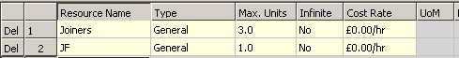
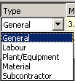
For advanced resourcing, you can analyse resources as Labour, Plant, Materials and Subcontractors.

If you decide to analyse resources in this way, then you should not choose GENERAL as a type.

PLANT & EQUIPMENT

If you wish to control and cost Plant as well as Labour, you will need to easily filter resource/cost reporting based on which TYPE it is.

MATERIALS

You can add materials to tasks and cost them per unit and you can input a LEAD TIME and then you can report a Materials Schedule of when materials need to be ordered.

LABOUR and PLANT

These TYPE resources work exactly the same as if they were General resources. You can still use Resource Driven tasks – but they will only schedule using the Labour work and will ignore Plant hours and Materials when calculating durations.

The set them up in the VIEW menu RESOURCE SHEET ..
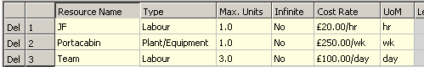

For non General resource, you have extra cost rate options - per Hour, Day & Week.

Multiple resources can be assigned to any one task ..
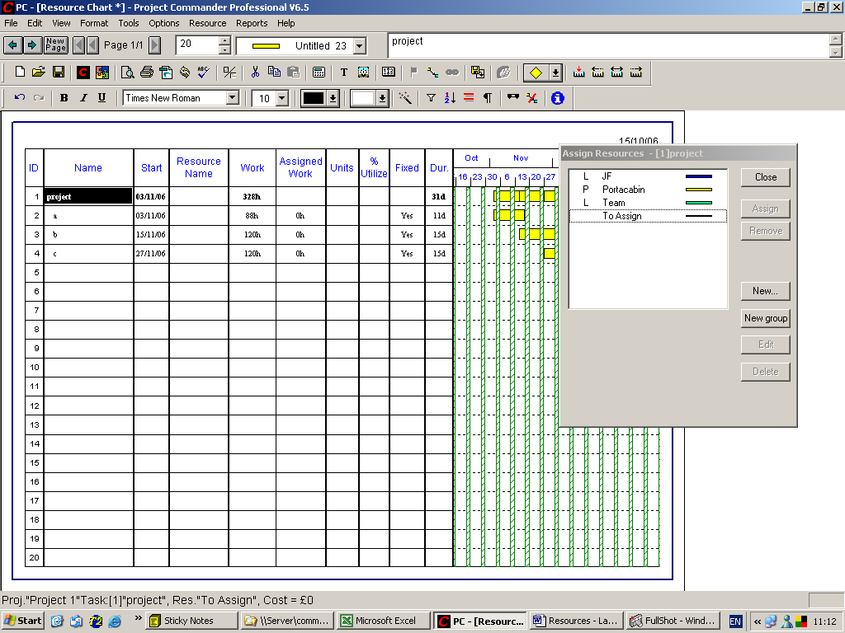

Here we assign all 3 resources to Task a (where we have changed the FIXED column to YES.
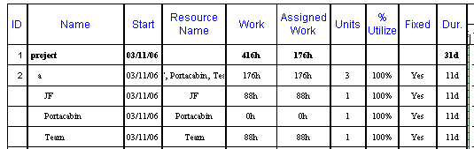

In the RESOURCE CHART view, WORK is only recorded against the Labour Resources and not against the Plant.

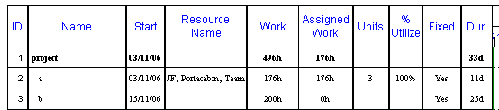

Here we assign the TEAM to the task and change the WORK to 200hours and assign the Plant. For a task that is RESOURCE DRIVEN, we change FIXED to NO for task B.

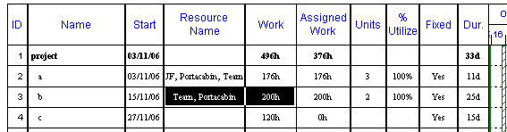

If you now change the number of the TEAM to 2, it will reduce the task duration using the Labour resource only ..
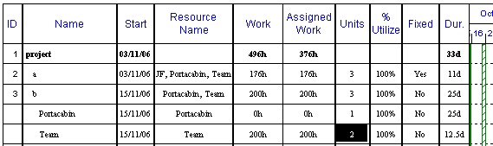

This will change the duration for the TEAM down by half. However, the Plant still shows the original duration – so it needs to be reduced manually (by double clicking on the word PORTACABIN ..
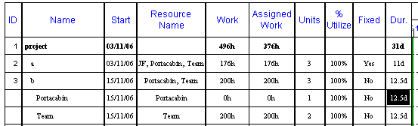

No resources are assigned to Task C – so the ASSIGNED WORK column is higher than the WORK column – as a default resource is assigned to every task until a resource is assigned.

LABOUR and PLANT - REPORTS

When you use the REPORTS, RESOURCES then all the resources are initially listed ..
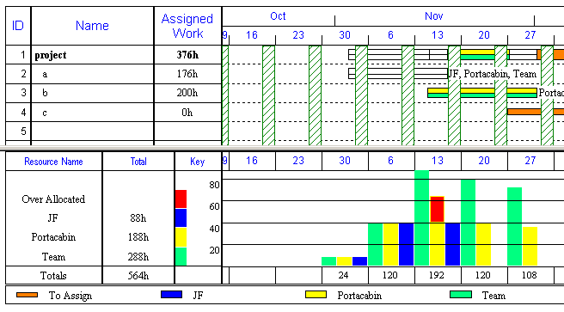

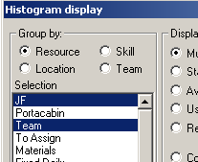
The ASSIGNED WORK column will not include the Hours associated with Plant & Equipment.

In order to not include the non labour resources in the resource analysis, select the RESOURCE menu, DISPLAY HISTOGRAM and click the highlight OFF the PORTACABIN and then click on OK.

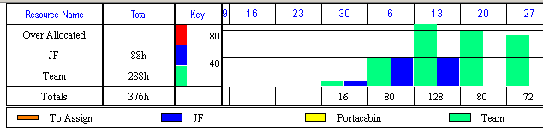

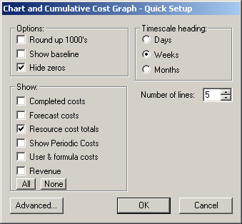
In Cost reports, you can list all Resource costs by clicking on a RESOURCE COST TOTALS

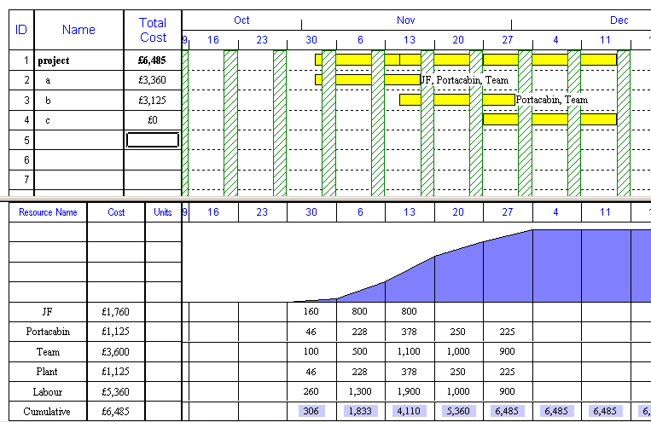

If you require just the RESOURCE TYPE or just the Resource list, RESOURCE menu, DISPLAY HISTOGRAM and deselect the items you wish to omit …

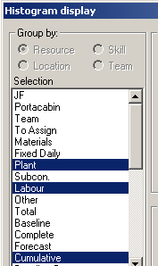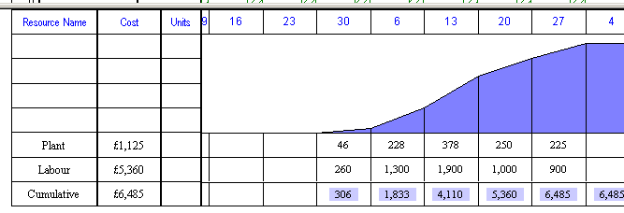

Above only the RESOURCE TYPES are left highlighted.

It is possible to filter the chart based on the RESOURCE TYPE. Select the TOOLS menu, FILTER and RESOURCE TYPE.

Here we just show tasks that have Plant resources
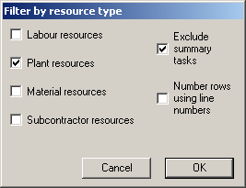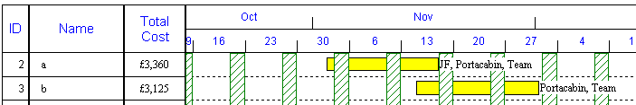

MATERIALS

Material Costs can input as a figure, but if you need to list several materials against a task, then you must add Material Resources …

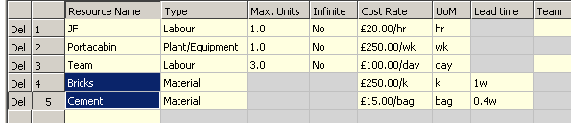

The UoM is the unit of measure and the cost rate is per unit.

When you assign a Material, the window asks for a QUANTITY

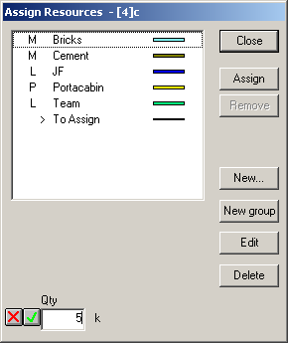

If you assign both materials, it will look like this using the VIEW menu, MORE VIEWS, MATERIAL SCHEDULE …
